St Joseph’s Catholic Primary School, Worcester

Child on Child Abuse (Including harassment and violence)

This policy is reviewed at least annually by the local governing body and was

Last reviewed on Date: August 2026
Next Review Date: August 2027
Signature: V Brennan
Print Name: Dr Vincent Brennan

This policy has been reviewed; to the best of our knowledge, we do not feel it impacts negatively on any specific group or individual within our school community.

Role | Name | Email address | Contact Number
Designated Safeguarding Lead (DSL) | Mrs Louise Bury | lbury@emmausmac.com | 01905 452772
Deputy DSL | Miss Marina Annese  Mrs Abigail Hackley  Mrs Nicola Boswell  Mr William Bowring  Mrs Lorelei Gifford (SENDCO)  Ms Alex Cree | mannese@emmausmac.com  ahackley@emmausmac.com  nboswell@emmausmac.com  Wbowring-lossack@emmausmac.com  lgifford@emmausmac.com  acree@emmausmac.com | 01905 452772

Contents
Table of Contents
Child on Child Abuse (Including harassment and violence) 0
1. Context and Definition 2
2. Responsibility 3
3. Purpose of Policy 3
4. Framework and Legislation 4
5. Abuse and harmful behaviour 4
6. Types of abuse 5
7. Expected Staff Action 8
8 Points to consider 10
9. Next Steps 11
10 Preventative Strategies 12
11. Where to go for further information 12
ANNEX A - Risk Assessment 14

Context and Definition

The staff of St Joseph’s Catholic Primary School who work with children are advised to maintain an attitude of ‘it could happen here’ where safeguarding is concerned. When concerned about the welfare of a child, staff should always act in the best interests of the child.

Child-on-child abuse, as defined in Keeping Children Safe in Education guidance (KCSIE), refers to abuse or harassment that occurs between children. This can include physical, sexual, or emotional abuse, as well as online bullying and harassment. Schools and colleges are expected to have policies and procedures in place to address this issue, including reporting, investigation, and support for both victims and those accused of abuse.

We are aware of:

Making clear that there is a zero-tolerance approach to sexual violence and sexual harassment, that it is never acceptable, and it will not be tolerated. It should never be passed off as “banter”, “just having a laugh”, “a part of growing up” or “boys being boys”. Failure to do so can lead to a culture of unacceptable behaviour, an unsafe environment and in worst case scenarios a culture that normalises abuse, leading to children accepting it as normal and not coming forward to report it –

- recognising, acknowledging, and understanding the scale of harassment and abuse and that even if there are no reports it does not mean it is not happening, it may be the case that it is just not being reported
- challenging physical behaviour (potentially criminal in nature) such as grabbing bottoms, breasts and genitalia, pulling down trousers, flicking bras and lifting up skirts. Dismissing or tolerating such behaviours risks normalising them

Child on Child abuse is behaviour by an individual or group, intending to hurt others physically, sexually or emotionally.

All our staff recognise that children are capable of abusing their peers. All staff should be aware of safeguarding issues from child-on-child abuse including:

- bullying (including online bullying)
- physical abuse such as hitting, kicking, shaking, biting, hair pulling, or otherwise causing physical harm
- sexual violence and sexual harassment
- sexting (also known as youth produced sexual imagery); and
- initiation/hazing type violence and rituals.

This abuse can:

- Be motivated by perceived differences e.g. on grounds of race, religion, gender, sexual orientation, disability or other differences
- Result in significant, long lasting and traumatic isolation, intimidation or violence to the victim; vulnerable adults are at particular risk of harm
Children or young people who harm others may have additional or complex needs e.g.:

- Significant disruption in their own lives
- Exposure to domestic abuse or witnessing or suffering abuse
- Educational under-achievement
- Involved in crime

Stopping violence and ensuring immediate physical safety is the first priority of any education setting, but emotional bullying can sometimes be more damaging than physical. School staff, alongside their Designated Safeguarding Lead and/or Deputies, have to make their own judgements about each specific case and should use this policy guidance to help.

Responsibility

Our staff are aware of the reporting systems within our school which support safeguarding, and these should be explained to them as part of staff induction. This should include the:

- Safeguarding/child protection policy (which should amongst other things also include the policy and procedures to deal with child-on-child abuse)

It also emphasises that the voice of the child must be heard

‘Local governing bodies, proprietors and school leaders should ensure the child’s wishes and feelings are taken into account when determining what action to take and what services to provide. Systems should be in place for children to express their views and give feedback. Ultimately, all system and processes should operate with the best interests of the child at their heart.’

Governing bodies and proprietors should ensure that the school or college contributes to multi-agency working in line with statutory guidance Working Together to Safeguard Children part 2.

Role of the DSL
The DSL will:
- Lead responses to all child-on-child abuse concerns.
- Ensure concerns are risk assessed.
- Maintain accurate safeguarding records.
- Coordinate support for victims.
- Assess risks posed by alleged perpetrators.
- Liaise with children's social care, police and other agencies.
- Monitor patterns and trends.
- Report safeguarding themes to governors

Child on child abuse is referenced in the Safeguarding and Child Protection Policy. The sensitive nature and specific issues involved with child on child necessitate separate policy guidance.

At St Joseph’s Worcester we continue to ensure that any form of abuse or harmful behaviour is dealt with immediately and consistently to reduce the extent of harm to the young person, with full consideration to the impact on that individual child’s emotional and mental health and well-being.

Purpose of Policy
The purpose of this policy is to explore some forms of child on child. The policy also includes a planned and supportive response to the issues.
At St Joseph’s Worcester we have the following policies in place that should be read in conjunction with this policy:

  - Anti-Bullying including Online Bullying Policy
  - Safeguarding and Child Protection Policy
  - Managing Allegations / Whistleblowing Policy
  - Behaviour Policy
  - Health & Safety Policy
  - Online Safety Policy

Framework and Legislation

This policy is supported by the key principles of the Children’s Act, 1989 that the child’s welfare is paramount. Another key document is Working Together, 2026 highlighting that every assessment of a child, ‘must be informed by the views of the child’. (Working Together, 2026) This is echoed by Keeping Children Safe in Education, 2026 through ensuring procedures are in place in schools and settings to hear the voice of the child.

Abuse and harmful behaviour

It is necessary to consider
- what abuse is and what it looks like
- how it can be managed
- what appropriate support and intervention can be put in place to meet the needs of the individual
- what preventative strategies may be put in place to reduce further risk of harm.

As a school we adopt a zero-tolerance approach to sexual violence and sexual harassment, that it is never acceptable, and it will not be tolerated. It should never be passed off as “banter”, “just having a laugh”, “a part of growing up” or “boys being boys”. Failure to do so can lead to a culture of unacceptable behaviour, an unsafe environment and in worst case scenarios a culture that normalises abuse, leading to children accepting it as normal and not coming forward to report it

- Children are vulnerable to abuse by their peers. Such abuse should be taken as seriously as abuse by adults and should be subject to the same child protection procedures.
- Children can abuse other children. This can include (but is not limited to): abuse within intimate partner relationships; bullying (including cyberbullying); sexual violence and sexual harassment; physical abuse such as hitting, kicking, shaking, biting, hair pulling, or otherwise causing physical harm; sexting and initiation/hazing type violence and rituals.
- Staff should be aware of the potential uses of information technology for bullying and abusive behaviour between young people.
- Staff should be aware of the added vulnerability of children and young people who have been the victims of violent crime (for example mugging), including the risk that they may respond to this by abusing younger or weaker children.

The alleged perpetrator is likely to have considerable unmet needs as well as posing a significant risk of harm to other children. Evidence suggests that such children may have suffered considerable disruption in their lives, may have witnessed or been subjected to physical or sexual abuse, may have problems in their educational development and may have committed other offences. They may therefore be suffering, or be at risk of suffering, significant harm and be in need of protection. Any long-term plan to reduce the risk posed by the alleged perpetrator must address their needs.

Types of abuse

There are many forms of abuse that may occur between peers and this list is not exhaustive. Each form of abuse or prejudiced behaviour is described in detail followed by advice and support on actions to be taken.

6.1 Physical abuse

This may include hitting, kicking, nipping/pinching, shaking, biting, hair pulling, or otherwise causing physical harm to another person. There may be many reasons why a child harms another and it is important to understand why a young person has engaged in such behaviour, including accidently before considering the action or punishment to be undertaken.

6.2 Sexual violence and sexual harassment

This must always be referred immediately to the Designated Safeguarding Lead.
Sexual violence and sexual harassment can occur between two children of any age and sex. It can also occur through a group of children sexually assaulting or sexually harassing a single child or group of children.

Sexually harmful behaviour from young people is not always contrived or with the intent to harm others. There may be many reasons why a young person engages in sexually harmful behaviour and it may be just as distressing to the young person who instigates it as to the young person it is intended towards. Sexually harmful behaviour may include

- inappropriate sexual language
- inappropriate role play
- sexual touching
- sexual assault/abuse.

Staff should be aware of the importance of:

- making clear that sexual violence and sexual harassment is not acceptable, will never be tolerated and is not an inevitable part of growing up
- not tolerating or dismissing sexual violence or sexual harassment as “banter”, “part of growing up”, “just having a laugh” or “boys being boys”; and
- challenging behaviours (potentially criminal in nature), such as grabbing bottoms, breasts and genitalia, flicking bras and lifting up skirts. Dismissing or tolerating such behaviours risks normalising them
- Upskirting: where someone takes a picture under a person’s clothing (not necessarily a skirt) without permission and or knowledge, with the intention of viewing their genitals or buttocks (with or without underwear) to obtain sexual gratification, or cause the victim humiliation, distress or alarm. It is a criminal offence. Anyone of any gender, can be a victim

6.3 Bullying

Bullying is unwanted, aggressive behaviour among school aged children that involves a real or perceived power imbalance. The behaviour is repeated, or has the potential to be repeated, over time. Both young people who are bullied and who bully others may have serious, lasting problems.

In order to be considered bullying, the behaviour must be aggressive and include:

- An Imbalance of Power: Young people who bully use their power—such as physical strength, access to embarrassing information, or popularity—to control or harm others. Power imbalances can change over time and in different situations, even if they involve the same people.
- Repetition: Bullying behaviours happen more than once or have the potential to happen more than once.

Bullying includes actions such as making threats, spreading rumours, attacking someone physically or verbally or for a particular reason e.g. size, hair colour, gender, sexual orientation, and excluding someone from a group on purpose.

6.4 Online Bullying

Online Bullying is the use of technology (social networking, messaging, text messages, e- mail, chat rooms etc.) to harass threaten or intimidate someone for the same reasons as stated above.
- Online bullying can take many forms
- Abusive or threatening texts, emails or messages
- Posting abusive comments on social media sites
- Sharing humiliating videos or photos of someone else
- Stealing someone’s online identity
- Spreading rumours online
- Trolling – sending someone menacing or upsetting messages through social networks, chatrooms or games
- Developing hate sites about another person
- Prank calls or messages
- Group bullying or exclusion online
- Anonymous messaging
- Encouraging a young person to self-harm
- Pressuring children to send sexual messages or engaging in sexual conversations

6.5 Sexting / Sharing nude or indecent imagery

The sharing of nudes and semi-nudes refers to the sending, receiving, creating, possessing, or sharing of nude or semi-nude images, videos, or live-streamed content by children and young people through any electronic device or online platform. This includes content that is digitally altered or generated using artificial intelligence (AI), such as manipulated or deepfake images. Such incidents may occur with or without consent and can involve coercion, exploitation, harassment, child on child abuse, or criminal behaviour. We recognise that the sharing of nudes and semi-nudes is a safeguarding concern that requires a proportionate and child-centred response.

We will –

Never view, copy, print, share, store or save the imagery yourself, or ask a child to share or download – this is illegal (see note below).

Note: In exceptional circumstances, it may be necessary for the DSL (or equivalent) to view the image to safeguard the child or young person. That decision will be based on the professional judgement of the DSL (or equivalent).

If the imagery has been viewed by accident (e.g. if a young person has showed it to you before you could ask them not to), this will be reported to the DSL (or equivalent) and seek support.

Not delete the imagery or ask the young person to delete it.

Not ask the child/children or young person(s) who are involved in the incident to disclose information regarding the imagery. This is the responsibility of the DSL (or equivalent).

Not share information about the incident with other members of staff, the young person(s) it involves or their, or other, parents and/or carers.

Not say or do anything to blame or shame any young people involved.

Will explain to them that it will be reported and reassure them that they will receive support and help from the DSL (or equivalent). (DfE sharing nudes and semi nudes: how to respond to an incident overview 2024)

6.6 Serious Violence

Serious violence is a safeguarding concern that may involve physical assault, carrying, threatening with, or using weapons, and may be linked to peer conflict, bullying, criminal exploitation, gangs, or county lines activity.

All our staff are aware of the indicators that a child may be at risk of, or involved in, serious violence. These indicators may include an increase in absences, changes in behaviour or peer relationships, a decline in educational performance, unexplained injuries, possession of weapons, involvement in criminal activity, or signs of exploitation. Children with disrupted education, including those who have experienced suspension, exclusion, or placement in alternative provision, may be at increased risk.

Any concerns that a child is carrying a weapon, has used a weapon, or has expressed an intention to do so must be reported immediately to the Designated Safeguarding Lead (DSL) or a deputy. The DSL will assess the level of risk to the child and others, gather relevant information, and take appropriate action in line with local safeguarding procedures. This may include the development of a safety and support plan, engagement with parents/carers, referrals to external agencies, and where necessary, contacting the police.

We recognise the importance of early intervention and will work with partner agencies to provide timely support for children who are affected by or at risk of serious violence. Support may include access to trusted adults, mentoring, emotional wellbeing support, and targeted interventions to reduce risk and promote positive outcomes.

6.7 Initiation/Hazing

Hazing is a form of initiation ceremony which is used to induct newcomers into an organisation such as a private school, sports team etc. There are a number of different forms, from relatively mild rituals to severe and sometimes violent ceremonies. The ceremony welcomes newcomers by subjecting them to a series of trials which promote a bond between them. After the hazing is over, the newcomers also have something in common with older members of the organisation, because they all experienced it as part of a rite of passage. Many rituals involve humiliation, embarrassment, abuse, and harassment.

6.8 Prejudiced Behaviour

The term prejudice-related bullying refers to a range of hurtful behaviour, physical or emotional or both, which causes someone to feel powerless, worthless, excluded or marginalised, and which is connected with prejudices around belonging, identity and equality in wider society – for example disabilities and special educational needs, ethnic, cultural and religious backgrounds, gender, home life, (for example in relation to issues of care, parental occupation, poverty and social class) and sexual identity.

6.9 Teenage relationship abuse

Teenage relationship abuse is a pattern of actual or threatened acts of physical, sexual, and/or emotional abuse, perpetrated by an adolescent (between the ages of 13 and 18) against a current or former partner. Abuse may include insults, coercion, social sabotage, sexual harassment, threats and/or acts of physical or sexual abuse. The abusive teen uses this pattern of violent and coercive behaviour, in a heterosexual or same gender relationship, in order to gain power and maintain control over the partner. This abuse may be child sexual exploitation.

7. Expected Staff Action

Staff should consider the seriousness of the case and make a quick decision whether to inform the Designated Safeguarding Lead immediately before taking any further in-school actions.

7.1. Recognising child on child abuse

An assessment of an incident between peers should be completed and consider:

  - Chronological and developmental ages of everyone involved
  - Difference in their power or authority in relation to age, race, gender, physical, emotional or intellectual vulnerability
  - All alleged physical and verbal aspects of the behaviour and incident
  - Whether the behaviour involved inappropriate sexual knowledge or motivation
  - What was the degree of physical aggression, intimidation, threatening behaviour or bribery?
  - The effect on the victim
  - Any attempts to ensure the behaviour and incident is kept a secret
  - The child or young person’s motivation or reason for the behaviour, if they admit that it occurred
  - Whether this was a one-off incident, or longer in duration

It is important to deal with a situation of peer abuse immediately and sensitively. It is necessary to gather the information as soon as possible to get the true facts. It is equally important to deal with it sensitively and think about the language used and the impact of that language on both the children and the parents when they become involved. Avoid language that may create a ‘blame’ culture and leave a child labelled.

Staff will talk to the children in a calm and consistent manner. Staff will not be prejudiced, judgmental, dismissive or irresponsible in dealing with such sensitive matters.

7.2 Taking Action

- Always take complaints seriously
- Gain a statement of facts from the pupil(s)
- Assess needs of victim and alleged perpetrator
- Consider referral to Police or Social Care
- Contribute to multi-agency assessments
- Convene a risk management meeting
- Record all incidents and all action taken

7.3 Recording sexualised behaviour

- Be clear, explicit and non-avoidant, and avoid vague statements or euphemisms
- Record as soon as possible, as you can quickly forget or confuse detail
- Follow the prompts on your safeguarding and child protection recording form
- Use proper names for body parts but record exactly any language or vocabulary used by the child. Use the child’s exact words in quotation marks.
- Note where and when the incident happened and whether anyone else was around.

7.4 Gather the Facts

Speak to all the young people involved separately, gain a statement of facts from them and use consistent language and open questions for each account. Ask the young people to tell you what happened. Use open questions, ‘where, when, why, who’. (What happened? Who observed the incident? What was seen? What was heard? Did anyone intervene?). Do not interrogate or ask leading questions.

7.5 Consider the Intent

Has this been a deliberate or contrived situation for a young person to be able to harm another?

7.6 Decide on your next course of action

If you believe any young person to be at risk of significant harm you must report to the Designated Safeguarding Lead immediately; they will follow the school’s Safeguarding and Child Protection Policy.

If children’s social care FFD and the police intend to pursue this further, they may ask to interview the young people in school or they may ask for parents to come to school to be spoken to. It is important to be prepared for every situation and the potential time it may take.

7.7 Informing parents/carers

The best way to inform parents/carers is face to face. Although this may be time consuming, the nature of the incident and the type of harm/abuse a young person may be suffering can cause fear and anxiety to parents/carers whether their child is the child who was harmed or who harmed another.

Is the pupil 13+ and does not want to share with parents? Use the ‘Gillick’ test and the ‘Fraser’ guidelines. Gillick competence and Fraser guidelines | NSPCC Learning

In all circumstances where the risk of harm to the child is evident then the school should encourage the young person to share the information with their parent/carer (they may be scared to tell parents/carers that they are being harmed in any way).

8 Points to consider

8.1 What is the age of the children involved?

How old are the young people involved in the incident and is there any age difference between those involved? In relation to sexual exploration, children under the age of 5, in particular 1-4 year olds who are learning toileting skills may show a particular interest in exploration at around this stage. This, however, should not be overlooked.

8.2 Where did the incident or incidents take place?

Was the incident in an open, visible place to others? If so, was it observed? If not, is more, supervision required within this particular area?

8.3 What was the explanation by all children involved of what occurred?

Can each of the young people give the same explanation of the incident and also what is the effect on the young people involved? Is the incident seen to be bullying for example, in which case regular and repetitive? Is the version of one young person different from another and why?

8.4 What is each of the children’s own understanding of what occurred?

Do the young people know/understand what they are doing? E.g. do they have knowledge of body parts, of privacy and that it is inappropriate to touch? Is the young person’s explanation in relation to something they may have heard or been learning about that has prompted the behaviour? Is the behaviour deliberate and contrived? Does the young person have understanding of the impact of their behaviour on the other person?

8.5 Repetition

Has the behaviour been repeated to an individual on more than one occasion? In the same way it must be considered has the behaviour persisted to an individual after the issue has already been discussed or dealt with and appropriately resolved?

9. Next Steps

Once the outcome of the incident(s) has been established it is necessary to ensure future incidents of abuse do not occur again and consider the support and intervention required for those involved

9.1 For the young person who has been harmed

What support they require depends on the individual young person. It may be that they wish to seek counselling or one to one support via a mentor. It may also be that they feel able to deal with the incident(s) on their own or with support of family and friends; in which case it is necessary that this young person continues to be monitored and offered support should they require it in the future. If the incidents are of a bullying nature, the young person may need support in improving peer groups/relationships with other young people, or some restorative justice work with all those involved may be required.

Other interventions that could be considered may target a whole class or year group for example a speaker on online bullying, relationship abuse etc. It may be that through the continued curriculum of Relationship and Sex Education Relationships Education, Relationships and Sex Education and Health Education guidance, PSHE and SMSC that certain issues can be discussed and debated more frequently.

If the young person feels particularly vulnerable it may be that a risk assessment can be put in place for them whilst in school so that they have someone named that they can talk to, support strategies for managing future issues and identified services to offer additional support.

9.2 For the young person who has displayed harmful behaviour

It is important to find out why the young person has behaved in such a way. It may be that the young person is experiencing their own difficulties and may even have been harmed themselves in a similar way. In such cases support such as one-to-one mentoring or counselling may also be necessary.

Particular support from identified services may be necessary through an early help referral and the young person may require additional support from family members.
Once the support required to meet the individual needs of the young person has been met, it is important that the young person receives a consequence for their behaviour. This may be in the form of restorative justice e.g. making amends with the young person they have targeted if this has been some form of bullying. In the cases of sexually harmful behaviour, it may be a requirement for the young person to engage in one-to-one work with a particular service or agency (if a crime has been committed this may be through the police or youth offending service). If there is any form of criminal investigation ongoing it may be that this young person cannot be educated on site until the investigation has concluded. In which case, the young person will need to be provided with appropriate support and education elsewhere.

It may be that the behaviour that the young person has displayed may continue to pose a risk to others, in which case an individual risk assessment may be required. This should be completed via a multi- agency response to ensure that the needs of the young person and the risks towards others are measured by all of those agencies involved including the young person and their parents. This may mean additional supervision of the young person or protective strategies if the young person feels at risk of engaging in further inappropriate or harmful behaviour.

The school may also choose a punishment as a consequence such as exclusion or internal exclusion/inclusion/seclusion for a period of time to allow the young person to reflect on their behaviour.

Further advice and guidance Lucy Faithful foundation which offers a confidential chat service supporting young people concerned about their own or someone else’s sexual thoughts and behaviours SHORE SPACE

9.3 After care

It is important that following the incident the young people involved continue to feel supported and receive help even if they have stated that they are managing the incident. Sometimes the feelings of remorse, regret or unhappiness may occur at a much later stage than the incident. It is important to ensure that the young people do not engage in any further harmful behaviour either towards someone else or to themselves as a way of coping (e.g. self-harm). For this reason, regular reviews with the young people following the incident(s) are imperative.

Preventative Strategies

Child on child abuse can and will occur on any site even with the most robust policies and support processes. It is important to develop appropriate strategies to proactively prevent child on child abuse.

This school has an open environment where young people feel safe to share information about anything that is upsetting or worrying them. There is a strong and positive PSHE/RSHE curriculum that tackles such issues as prejudiced behaviour and gives children an open forum to talk things through rather than seek one on one opportunities to be harmful to one another. The school makes sure that ‘support and report’ signposting is available to young people.

Staff will not dismiss issues as ‘banter’ or ‘growing up’ or compare them to their own experiences of childhood. Staff will consider each issue and each individual in their own right before taking action.

Young people are part of changing their circumstances and, through school council and pupil voice for example, we encourage young people to support changes and develop ‘rules of acceptable behaviour’. We involve pupils in the positive ethos in school; one where all young people understand the boundaries of behaviour before it becomes abusive.

Fig.1 Overview of child-on-child abuse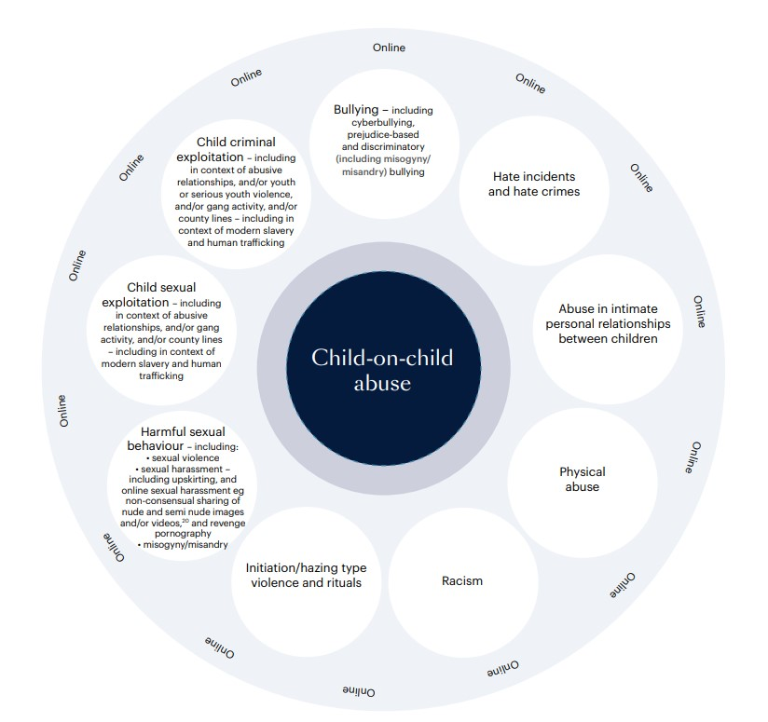

Fig 2 Sexual behaviours continuum model

Normal | Inappropriate | Problematic | Abusive | Violent
Developmentally expected  Socially acceptable  Consensual, mutual, reciprocal  Shared decision making | Single instances of inappropriate sexual behaviour  Socially acceptable behaviour within peer group  Context for behaviour may be inappropriate  Generally consensual and reciprocal | Problematic and concerning behaviours  Developmentally unusual and socially unexpected  No overt elements of victimisation  Consent issues may be unclear  May lack reciprocity or equal power  May include levels of compulsivity | Victimising intent or outcome  Includes misuse of power  Coercion and force to ensure victim compliance  Intrusive  Informed consent lacking, or not able to be freely given by victim  May include elements of expressive violence | Physically violent sexual abuse  Highly intrusive  Instrumental violence which is physiologically and/sexual arousing to the perpetrator  Sadism
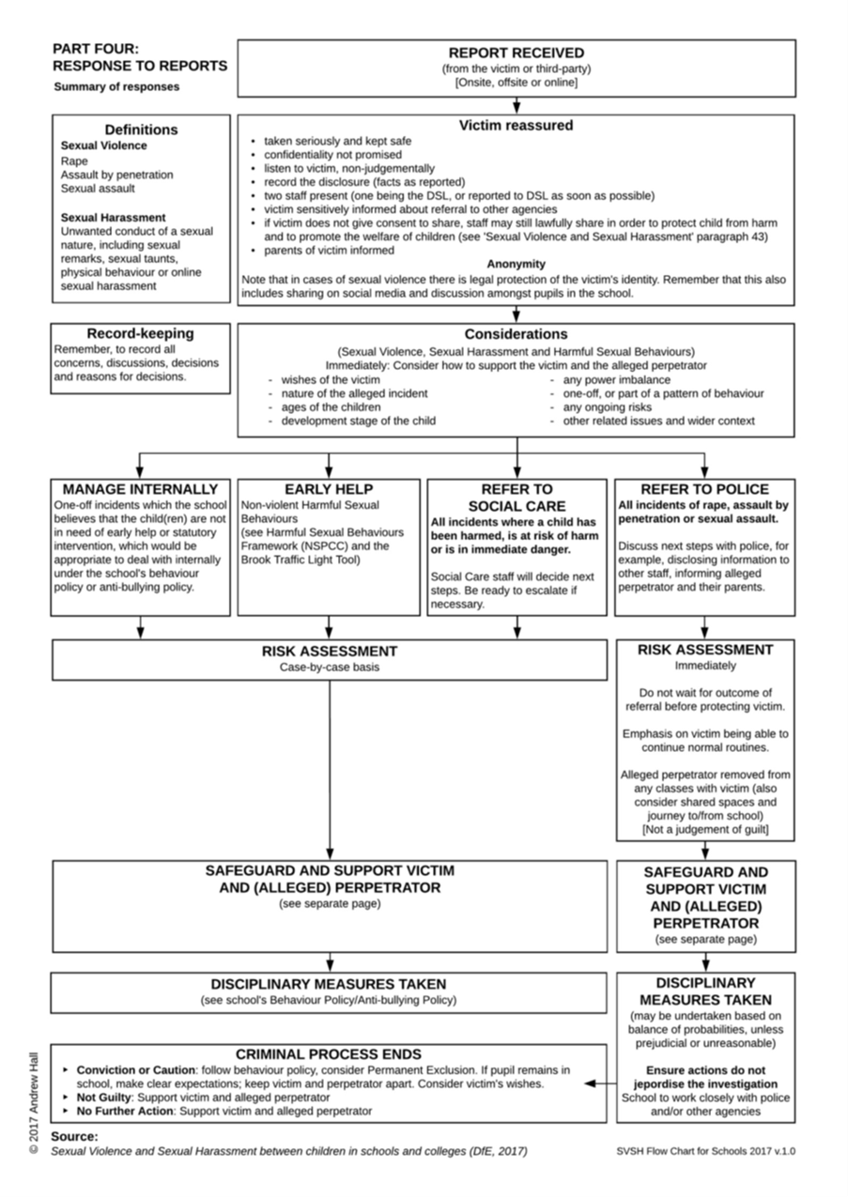
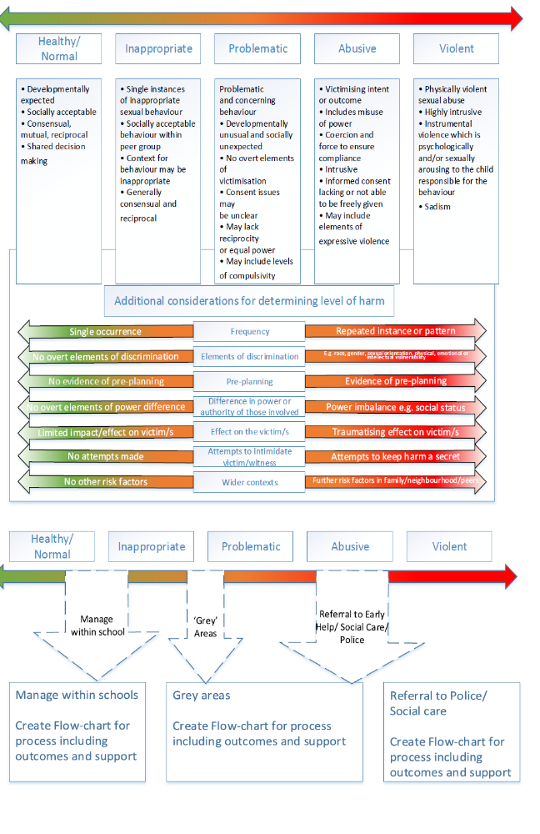

11. Where to go for further information

  - Working together to safeguard children 2026: statutory guidance (publishing.service.gov.uk)
  - Searching, Screening and Confiscation (publishing.service.gov.uk)
  - Keeping children safe in education 2026 (comes into force from 1 September 2026)
  - DfE: Preventing and Tackling Bullying, July 2017
  - Suspension and permanent exclusion guidance September 2024 (publishing.service.gov.uk)
  - Teaching online safety in schools - GOV.UK (www.gov.uk)
  - Behaviour in Schools - Advice for headteachers and school staff Feb 2024 (publishing.service.gov.uk)
  - DfE: Mental health and behaviour in schools, November 2018
  - DfE: Children Missing Education, August 2024
  - DfE: Mental health and behaviour in schools, November 2018
  - UKCIS: Sexting guidance for schools, 2024 (An updated copy of this guidance is due autumn term 2020)
  - Gov.uk: Equality Act 2010: advice for schools

ANNEX A - Risk Assessment

Basic information
Referrer Name and role
Referrer Contact details (email address and phone number)
Name of school(s) for victim(s)
Name of school(s) for child/ren alleged to have caused harm
Did incident occur on school premises? If not, where did the incident occur?

considerations | RISK (consider victim, Child alleged to have caused harm, other pupils and staff) | Risk Level (High, Medium or low) | actions to reduce risk | Revised Risk Level (High, Medium or low)
What is the incident?
Who was involved?
Where did it happen
Does this incident constitute a crime? Assault, sexual assault, rape, sharing of indecent images of children, etc etc. As such has this been referred to the police?
Is it necessary to limit contact between the children involved?
Refer to Keeping children safe in education 2026 (comes into force from 1 September 2026) PART 5 and DFE guidance on sexual harassment and sexual violence in schools and colleges.
Is there an actual or perceived threat from the child alleged to have caused harm to the victim and/or others?
Is either the victim or the child alleged to have caused harm at risk of physical harm as a result of this incident (for example, bullying or ‘retribution’ by peers)?
Do they share classes?
Do they share break times?
Do they share peer/friendship groups?
Do they share transport to/from school?
Are they likely to come into contact with each other (or anyone else involved in/with knowledge of the incident) outside of school?
How can such contact be limited?
Is there a risk of harm from social media and gossip?

Further action taken by the school or college: Please complete for each child involved.

Action | YES/NO | Date
Police informed
Referral to FFD
Referral to external support services
Referral to internal support services
Referral to CAMHS
Referral to early help
Internal Early Help and Support
Other

Action | YES/NO | Date
Police informed
Referral to FFD
Referral to external support services
Referral to internal support services
Referral to CAMHS
Referral to early help
Other

